**Email Configuration with Jenkins**

Jenkins comes with an out of box facility to add an email notification for a build project.

**Plugins**

# Email-ext plugin

# Email-ext Template plugin

## Project configuration

For a project to use the email-ext plugin, you need to enable it in the project configuration page.  Select the checkbox labeled "Editable Email Notification" in the  "Post-build Actions" section.

### Basic Configuration

There are three fields that you can edit when the plugin is enabled.

* **Global Recipient List** - This is a comma (or whitespace) separated list of email recipients.  Allows you to specify a single recipient list for each email that is sent.
* **Default Subject** - This allows you to configure a token (more about tokens later), that can be used to easily configure all email subjects for the project.
* **Default Content** - Same as Default Subject, but for the email body instead of the subject.

### Advanced configuration

To see the advanced configuration for the plugin, first click on Override Global setting checkbox, then click the "Advanced" button.  This section allows you to specify recipients for each type of email trigger as well as a pre-send script that can be used to modify the email just prior to sending.

#### Pre-send Script

The pre-send script is a feature which allows you to write a script that can modify the [MimeMessage](http://docs.oracle.com/javaee/1.4/api/javax/mail/internet/MimeMessage.html) object prior to sending. This would allow adding custom headers, modifying the body, etc. Predefined variables include:

* msg - the MimeMessage object which can be modified
* logger - a PrintStream and will write to the job's log.
* build - the build this message belongs to
* cancel - a boolean, which when set to true will cancel the sending of the email

#### Triggers

By default, the only trigger configured is the "Failure" trigger.  To add more triggers, select one from the dropdown, and it will be added to the list.  Once you have added a trigger, you have several options.  If you click "?" (question mark) next to a trigger, it will tell you what conditions must be met for it to send an email.

* **Send to Recipient List** - Check this checkbox if you would like to have the email sent to the "Global Recipient List" configured above.
* **Send to Developers** - Check this checkbox to send the email to anyone who checked in code for the last build.  The plugin will generate an email address based on the committer's id and an appended "default email suffix" from Jenkins's global configuration page.  For instance, if a change was committed by someone with an id "first.last", and the default email suffix is "@somewhere.com", then an email will be sent to "first.last@somewhere.com"
* **Send To Requester** - If this is checked, an email will be sent user who triggers the build (if triggered by a user manually).
* **Include Culprits** - If this is checked AND Send To Developers is checked, emails will include everyone who committed since the last successful build.
* **More Configuration** - Configure properties at a per-trigger level.
  + **Recipient List** - A comma (and whitespace) separated list of email address that should receive this email if it is triggered.  This list is appended to the "Global Recipient List" above.
  + **Subject** - Specify the subject line of the selected email.
  + **Content** - Specify the body of the selected email.
* **Remove** - Click the delete button next to an email trigger to remove it from the configured triggers list.

You can use Trigger Scripts in groovy to define before of after the build if the email must be send or not.

There are four objects added to the model for the script to use to interact with the build.

* **build**: This is the current build, usually a child class of AbstractBuild
* **project**: The project object that the current build was started from, usually a child class of AbstractProject
* **rooturl**: The Jenkins instance root URL, useful for links.
* **out**: A PrintStream that can be used to log messages to the build log.

**Plugins**

# Email-ext plugin

For Gmail

Below are the updated gmail SMTP server configuration :

Gmail SMTP server address: smtp.gmail.com

Gmail SMTP user name: Your full Gmail address (e.g. example@gmail.com)

Gmail SMTP password: Your Gmail password

Gmail SMTP port: 465

Gmail SMTP TLS/SSL required: yes

Issues: Token Macro plugin

To configure email (gmail) server with jenkins it is better if we use Email-ext plugin.  
Steps  
1. First go to Manage Jenkins > Manage Plugins  
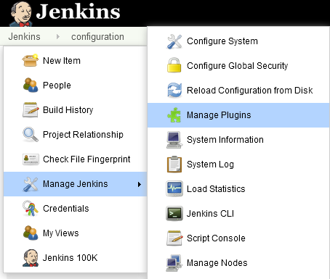

2. Click on Available tab and search for “Email-ext”  
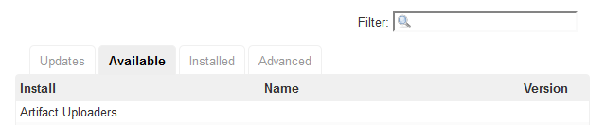

3. Install this plugin.  
4. Now goto Manage Jenkins > Configure System option  
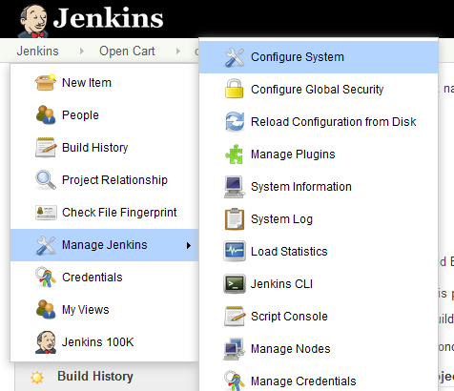

5. Scroll for “Extended E-mail Notification” and check “Override Global Settings” check box.  
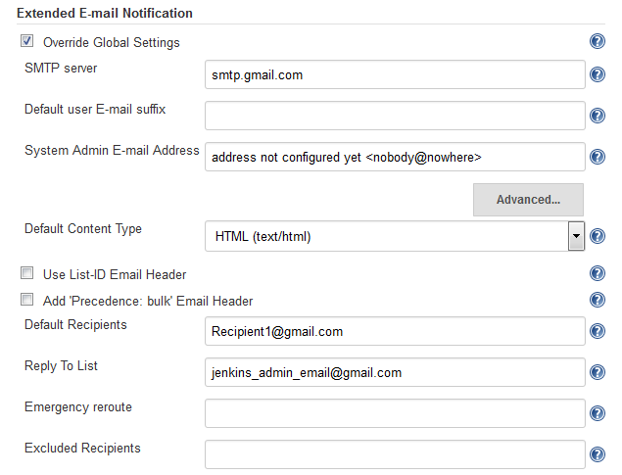

6. Click Advance and fill up the gmail details.  
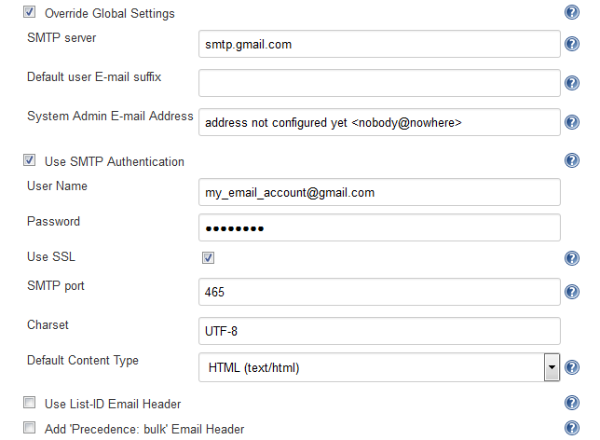

7. Now click Save button  
8. Now open our sample project and navigate to “Configure”  
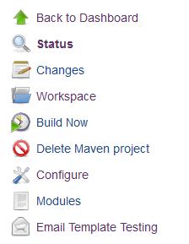

9. Search for “Post-build Actions”  
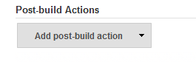

10. Click on Add button and select Editable Email Notification.  
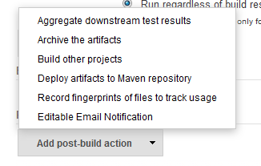

11. For basic purpose No need to change default settings. Just click on Advance Settings on below section  
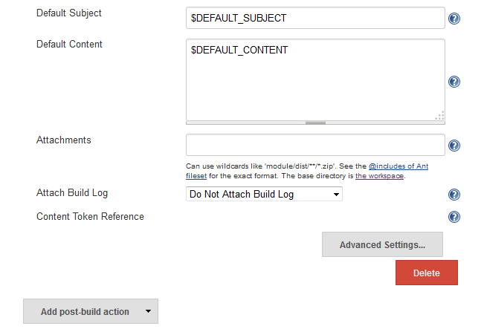

12. Now we will find Triggers, by default it configured as Failure Any.  
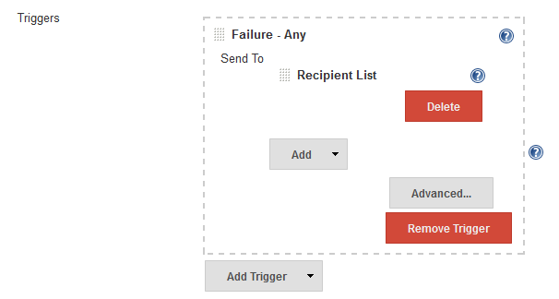

13. We can remove the trigger and add for Always, like –  
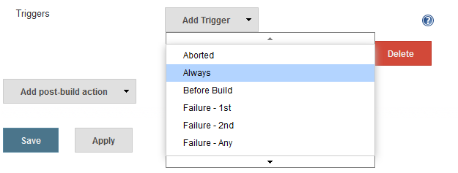

14. We can delete Developer and can only use Recipient list  
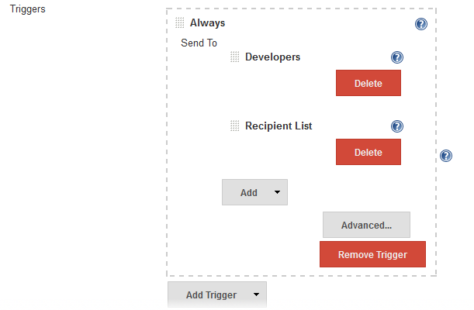

15. Finally click Save button.  
16. Now build the Project and if everything works fine , you will receive the mail.

For Email Plugins

1. Open Jenkins using the following URL: http://localhost:8080/ on any browser.

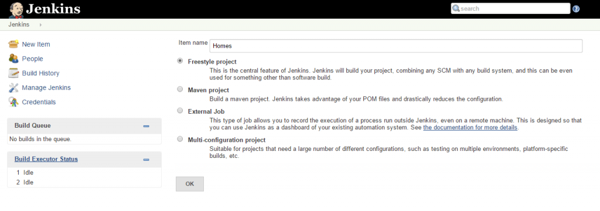

2. Click the ‘Manage Jenkins’ menu option displayed at the right side of the screen. You will be redirected to the ‘Manage Jenkins’ page, where you need to select the ‘Manage Plugin’ option.

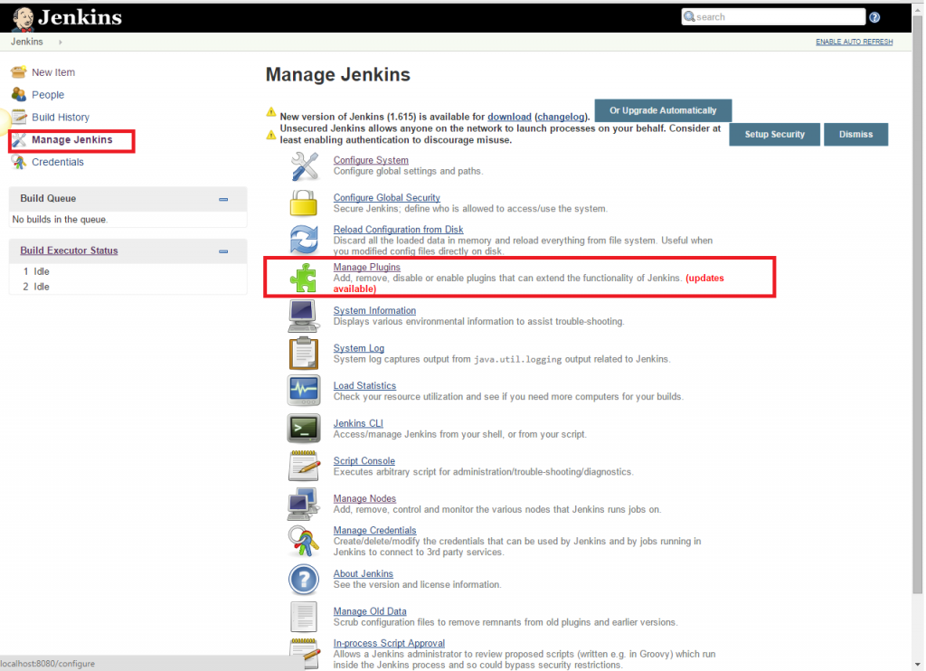

3. Click the ‘Available’ tab present at the top of the ‘Manage Plugin’ page.

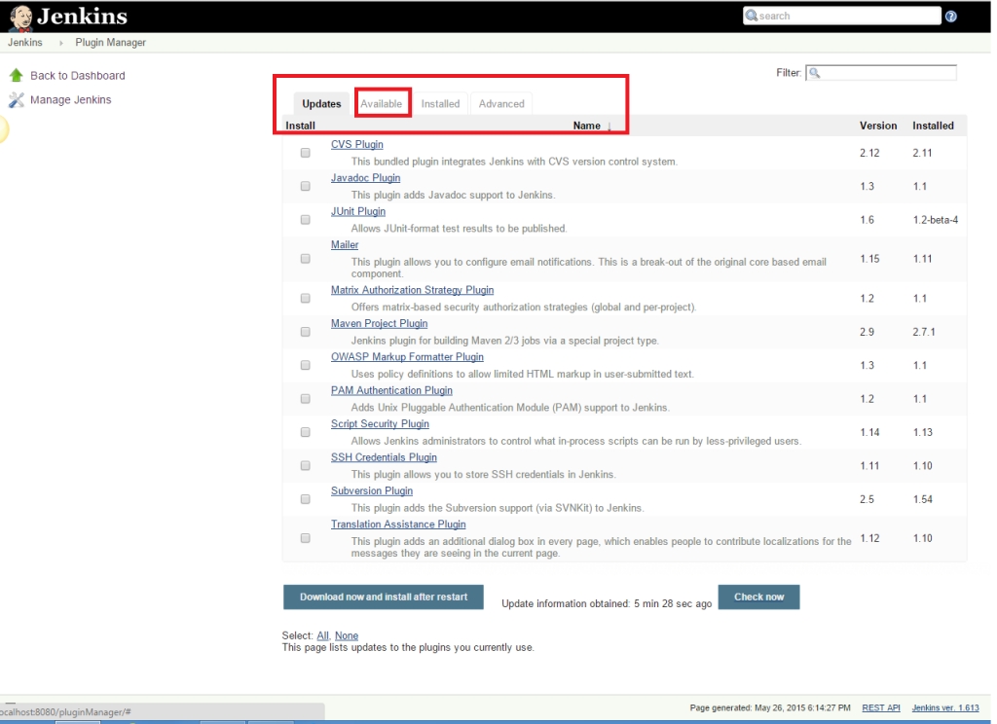

4. Start typing ‘Notification’ in the ‘Filter’ field displayed at the top-right side of the ‘Manage Plugin’ page. Click the checkbox next to the ‘Email-ext plugin’ option. Click the ‘Install without restart’ button.

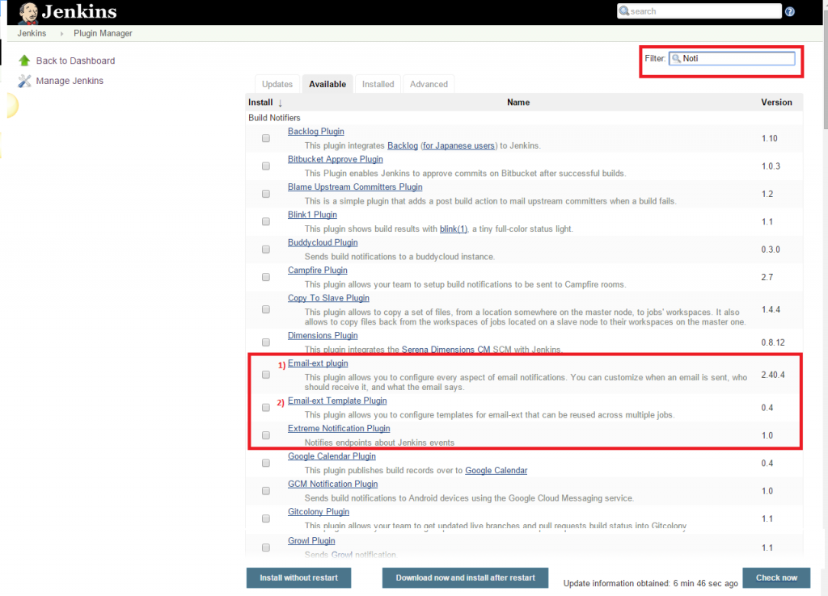

5. Now, click the checkbox next to the ‘Email-ext Template Plugin’ option. Click the ‘Install without restart’ button.

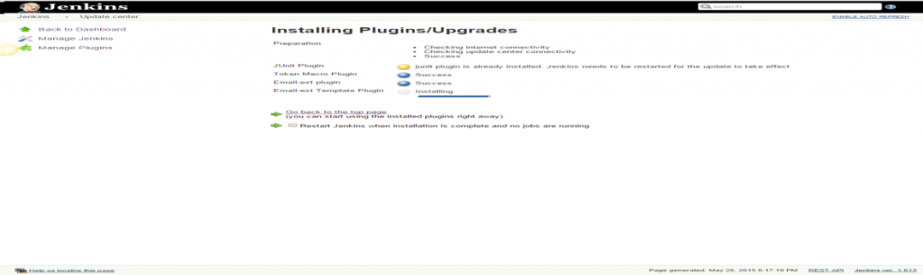

6. Go to the Jenkins home page and click the ‘Manage Jenkins’ menu option. Then, select the ‘Configure System’ option.

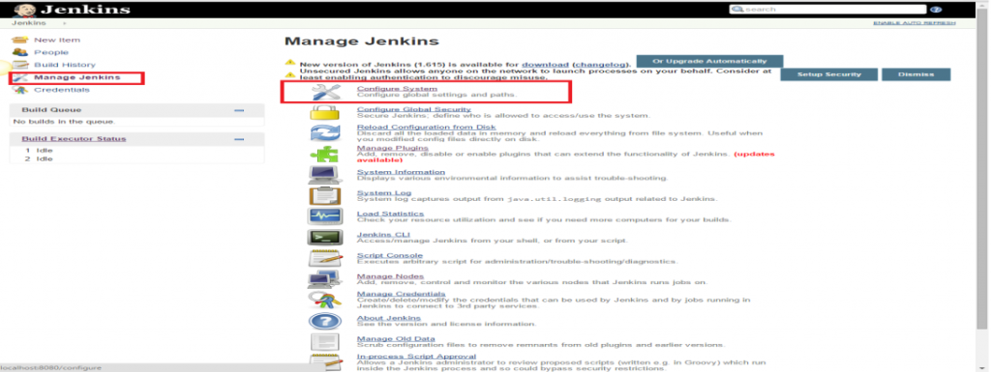

7. Enter the SMTP server name under ‘Email Notification’. Click the ‘Advanced’ button and then click the checkbox next to the ‘Use SMTP Authentication’ option. Now, set the following fields.

* + **SMTP server name** : smtp.gmail.com
  + **User name**: user_email_id@gmail.com
  + **Password**: 123456
  + **Use SSL** : Checked
  + **SMTP Port**: 456

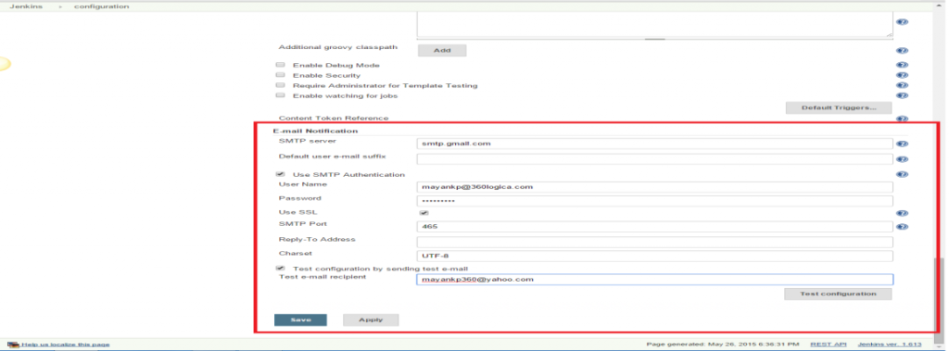

8. Check the email notification functionality by clicking the checkbox next to the ‘Test configuration by sending Test e-mail recipient’ option. Enter a valid email id and click the ‘Test configuration’ button to check whether the email id is valid or not.

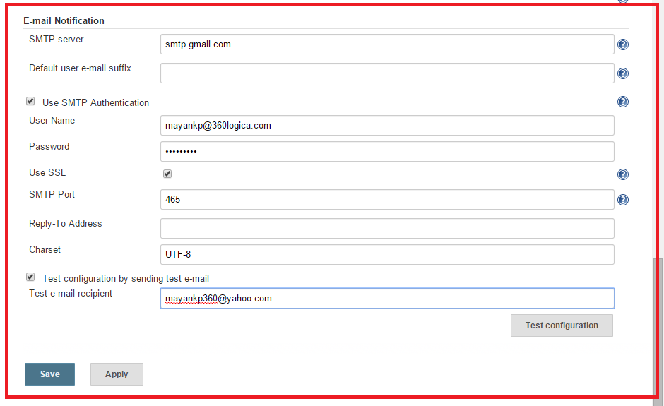

9. Go to the home page and click on a created job, like Homes. Then, click the ‘Configure’ option.

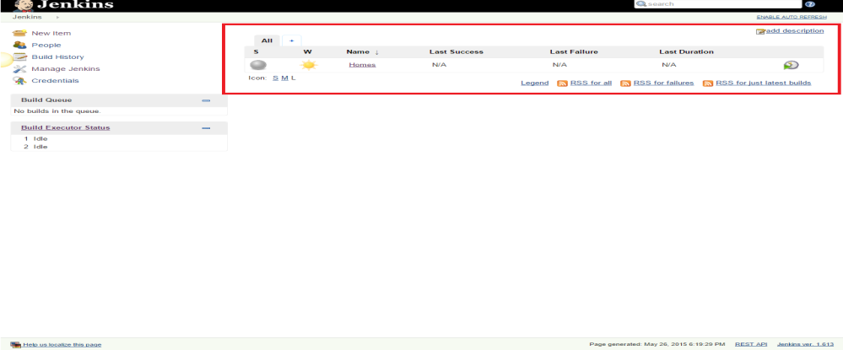

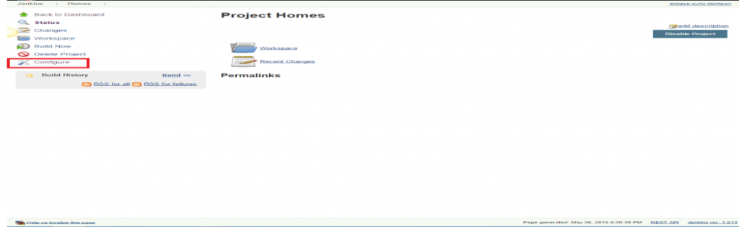

10. Click the ‘Add post-build action’ drop-down.

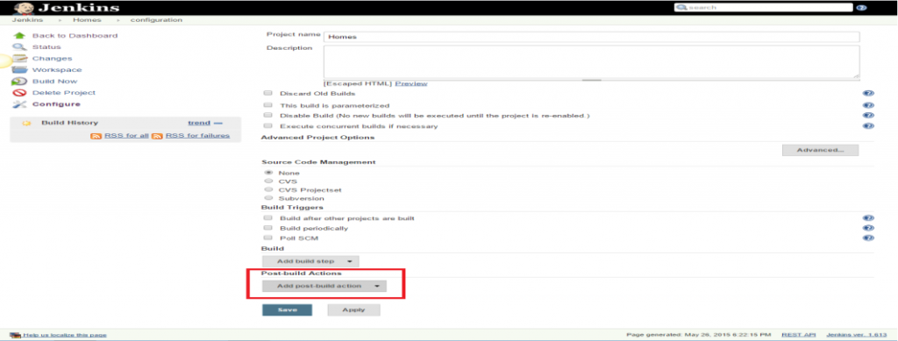

11. Select the ‘E-mail Notification’ value.

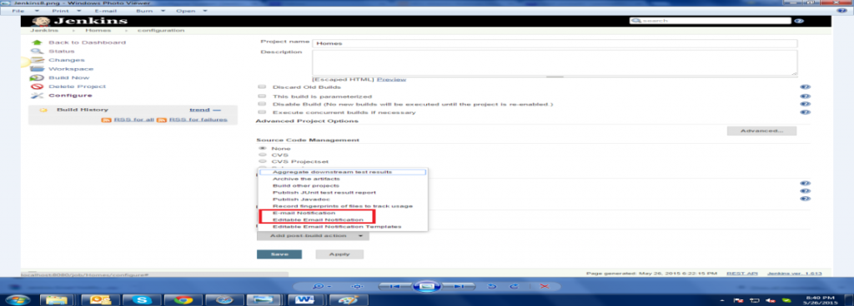

12. Enter the recipient email id in the ‘E-mail Notification’ box and select the checkbox next to the ‘Send e-mail for every unstable build’ option.

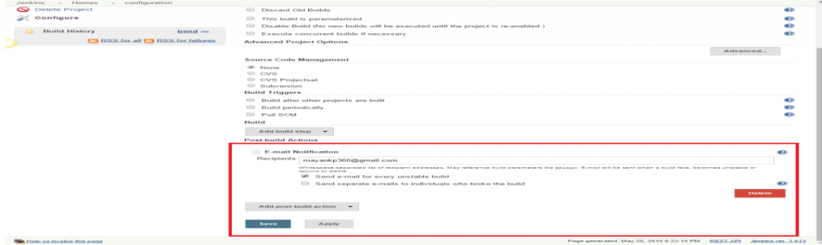

13. Click the ‘Add post-build action’ drop-down and select the ‘Editable Email Notification’ value.

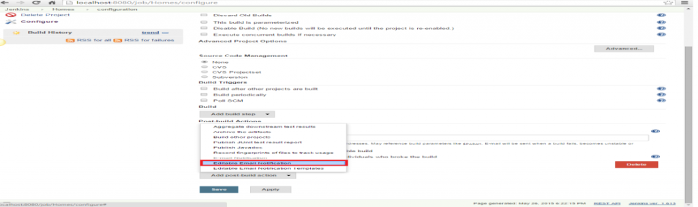

14. Fill the ‘Editable Email Notification’ fields.

* Project Recipient List : email_id@gmail.com

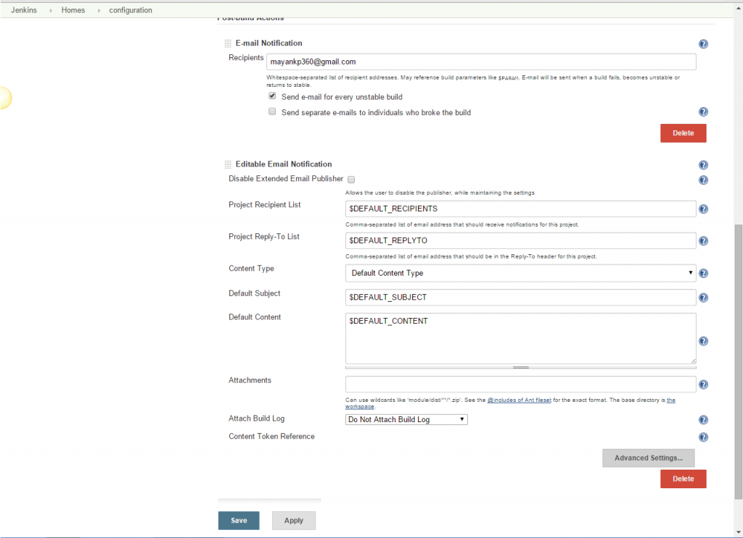

15. Click the ‘Advance Settings…’ button in the ‘Editable Email Notification’ box.

16. Click the ‘Add Trigger’ drop-down and select the ‘Always’ option.

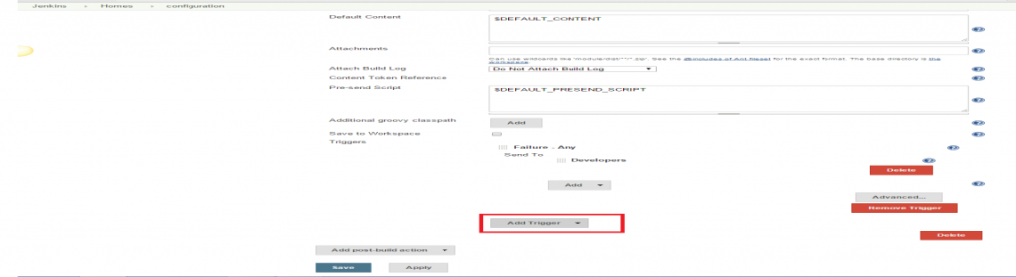

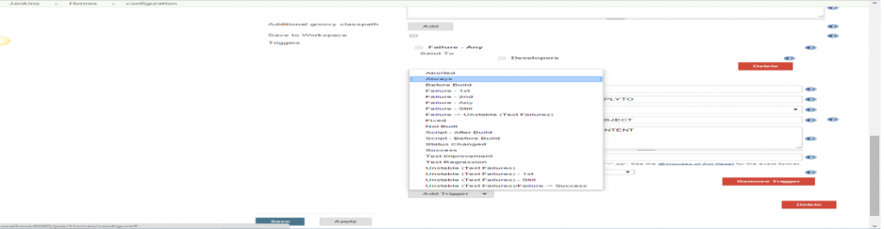

17. Click the ‘Save’ button.

18. Go to the home page and click on the job, like Homes.

19. Click the ‘Build now’ link and check the email id after the job execution.